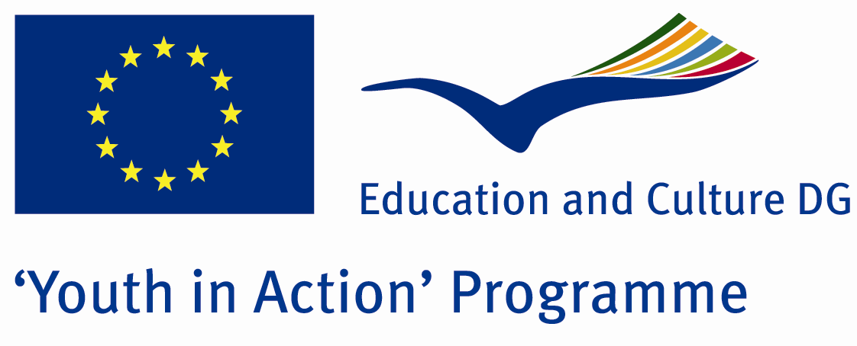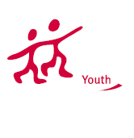

The Best Power:Nature
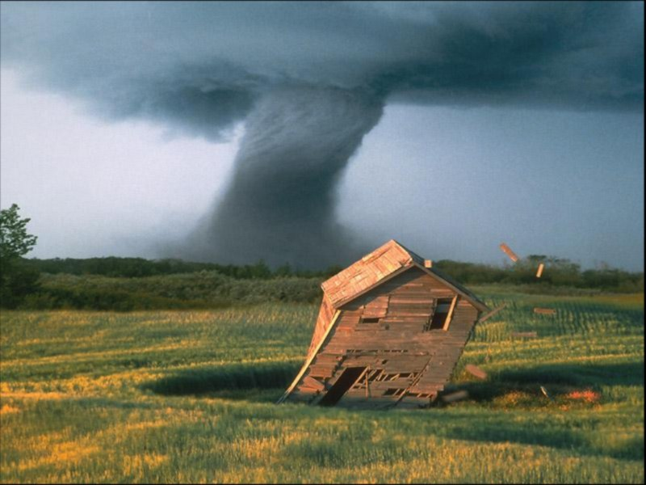

ACTION 1.1 – Youth Exchange

20-26th November 2011

Sakarya, TURKEY

Please contact directly to;
adventurerpeacepigeons@gmail.com

Project Summary;

It is a fact that in every country on the world we can see a natural disaster. But, how much information do we have about natural disasters as human beings? Do we know that there are ways to prevent them? So, how can we prevent natural disasters? İn this project answers to such questions will be found.

If you want to join this project, please contact us..

Project Title; The Best power:Nature

Date and Venue ; 20-26th November 2011, Sakarya, TURKEY

Target Group ; Municipalities, City Councils and Non-Governmental organizations,
youth groups,culture and art groups,e.t.c

Participants ; 5 people from each country (over 18 -25 ). Totally 8 countries.

Conditions ; Accommodation, board and programme costs will be financed through European Commission Youth in Action Programme (Action 4.3). Travel costs will be reimbursed in 70% (APEX Tarrifs). Organizations from all 27 EU member countries plus Liechtenstein , Norway and Iceland are eligible to take part.

Working language: English

Organizer; Adventurer Peace Pigeons

How to apply: If you are interested, please send your Part III forms to
by e-mail please (in word file). Scan Part3 format is enough for application.(Fulfilled Part III which you can find in the attachment, of course signed and stamped) ..

Next step 2;
Original send via regular post to this address please:
Ertan DERİN
Fevzi Çakmak Mahallesi Tuncer Sokak No:6 PENDİK/İSTANBUL/TÜRKİYE
e-mail : adventurerpeacepigeons@gmail.com
Mobile : 0090 542 393 93 90

If you have any questions you may contact with: adventurerpeacepigeons@gmail.com

Deadline for application; until 15th May 2011.

For Further information:
Contact Person
Ertan DERİN
Fevzi Çakmak Mahallesi Tuncer Sokak No:6 PENDİK/İSTANBUL/TÜRKİYE
e-mail : adventurerpeacepigeons@gmail.com
Mobile : 0090 542 393 93 90

